Maven Installation:

Windows

Download Maven

To install maven on windows, you need to download apache maven first.

Download Maven latest Maven software from [Download latest version of Maven](http://maven.apache.org/download.cgi)

<https://maven.apache.org/download.cgi>

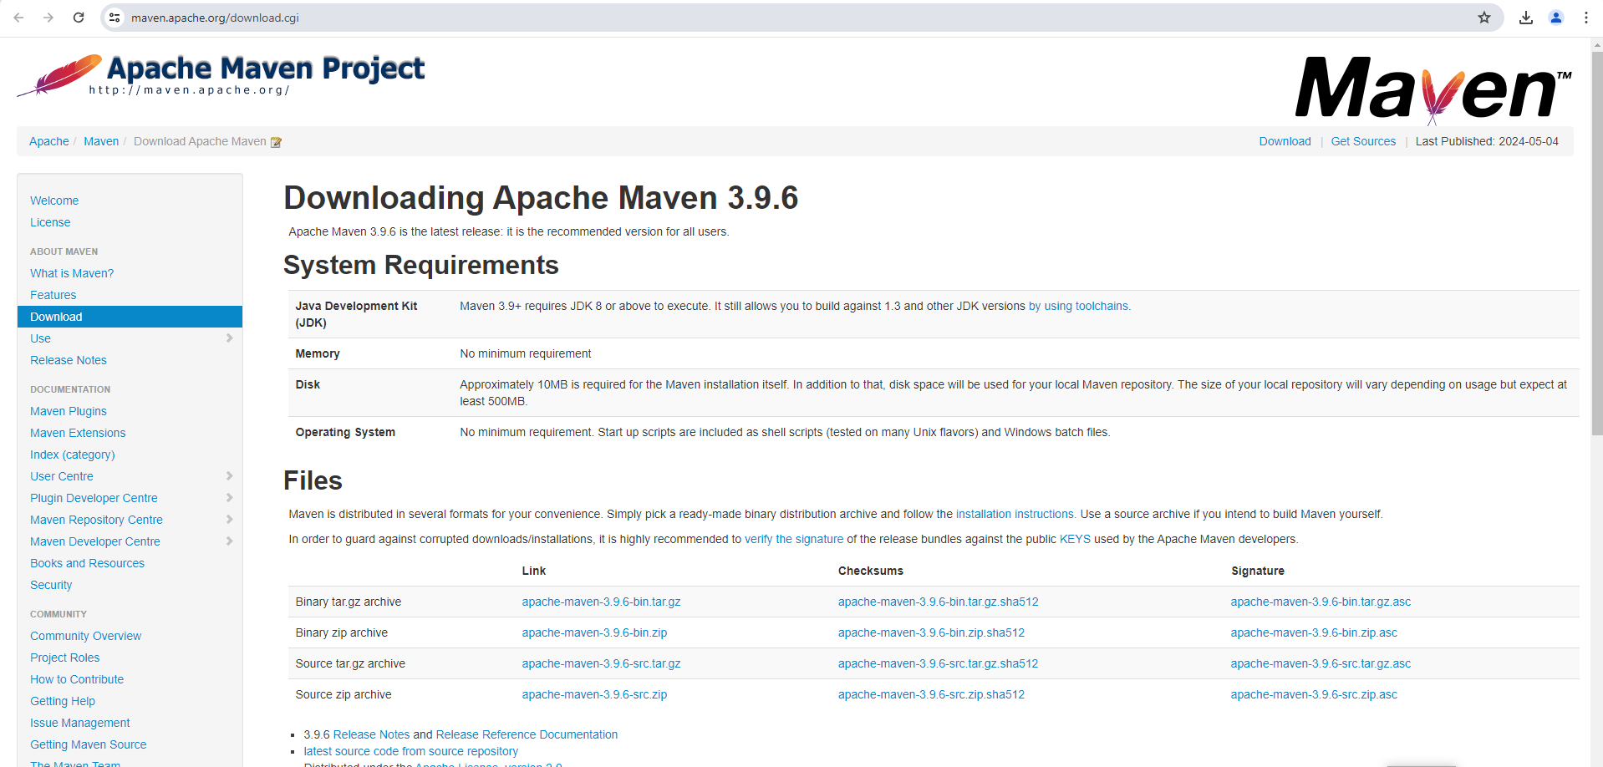

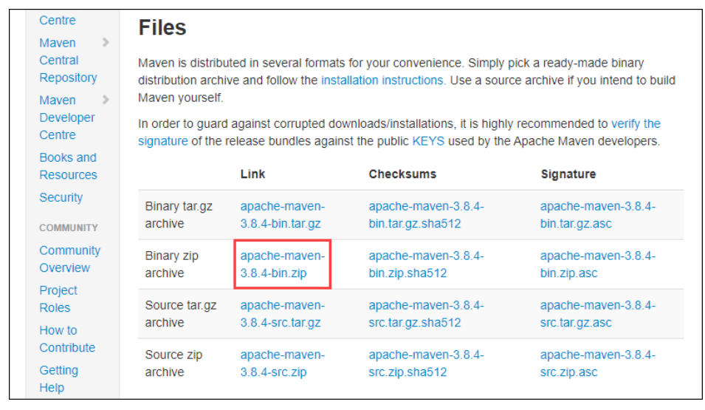

Extract the Maven archive to a directory of your choice once the download is complete

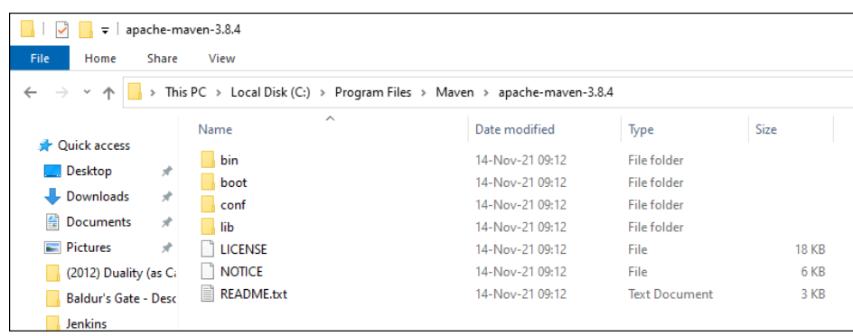

### Step 2: Add MAVEN_HOME System Variable

1. Open the Start menu and search for [environment variables](https://phoenixnap.com/kb/windows-set-environment-variable).

2. Click the **Edit the system environment variables** result.

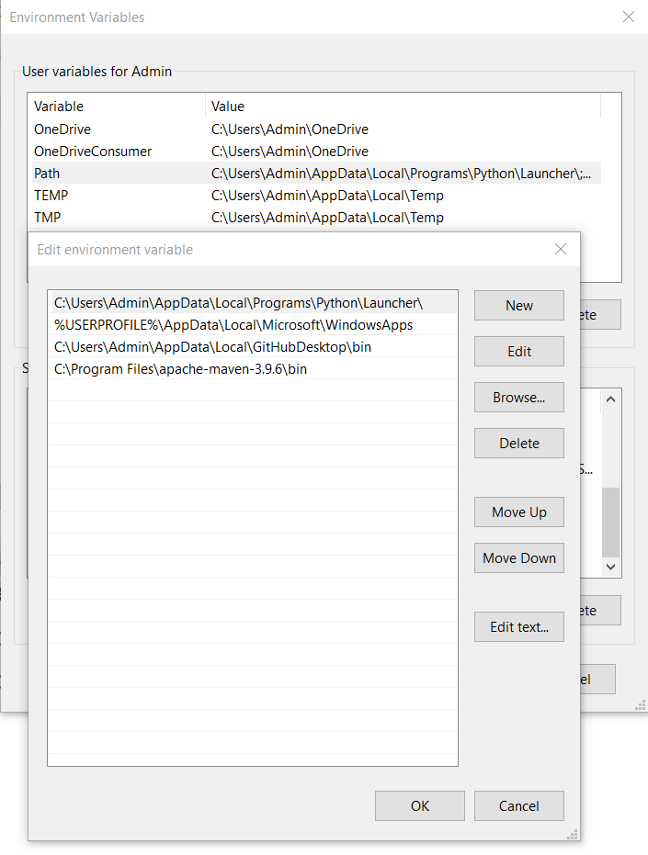

### Step 3: Add MAVEN_HOME Directory in PATH Variable

1. Select the **Path** variable under the System variables section in the Environment Variables window. Click the **Edit** button to edit the variable.

 Click the **New** button in the Edit environment variable window.

Enter **%MAVEN_HOME%\bin** in the new field. Click **OK** to save changes to the **Path** variable.

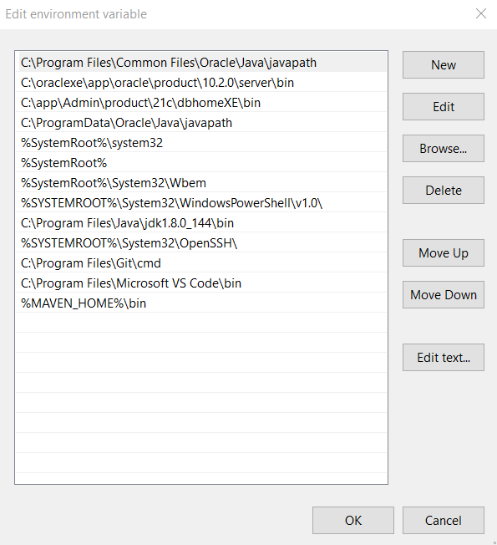

Click **OK** in the Environment Variables window to save the changes to the system variables.

### Step 4: Verify Maven Installation

In the command prompt, use the following command to verify the installation by checking the current version of Maven:

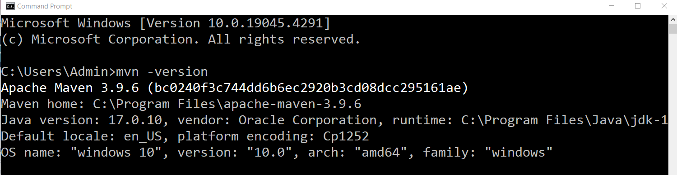

Maven Build requirements

Maven is primarily used to manage dependencies and build projects based on a project object model (POM).

**Java Development Kit (JDK):**

Maven requires JDK installed on your system. It's recommended to have JDK 1.7 or higher. You can download and install JDK

**Project Object Model (POM):**

Maven uses POM XML files to manage the project's build, dependencies, and other configuration details. Every Maven project should have a **pom.xml** file at the root of the project.

**Internet Connection:**

Downloads dependencies from remote repositories like Maven Central Repository.

**Repository Configuration:**

By default, Maven uses the Maven Central Repository. You can configure additional repositories in the **pom.xml** file if your project requires dependencies from other repositories.

# Creating First Maven Project using command line

**Step 1:** To generate new project use the command

mvn archetype:generate

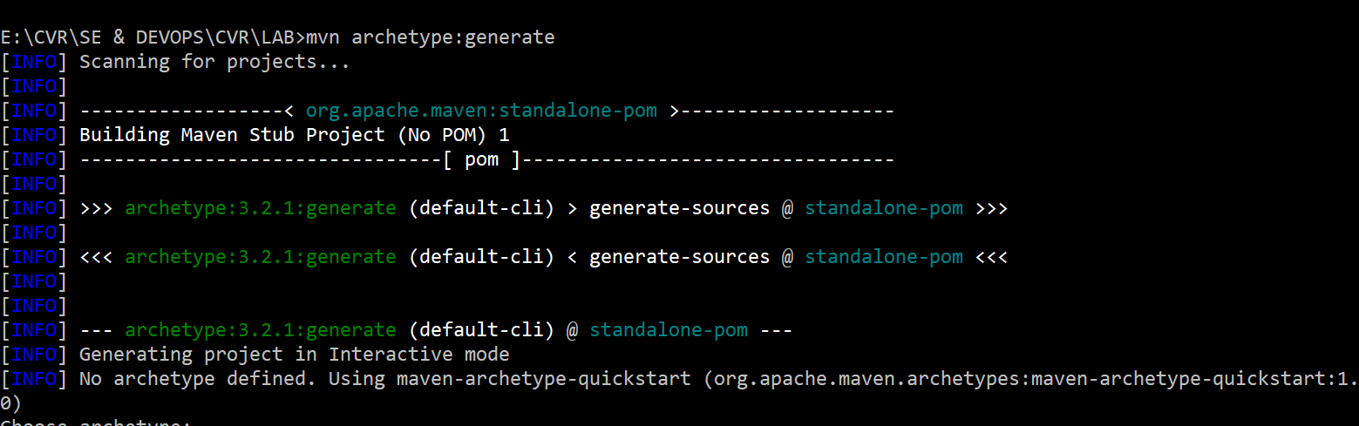

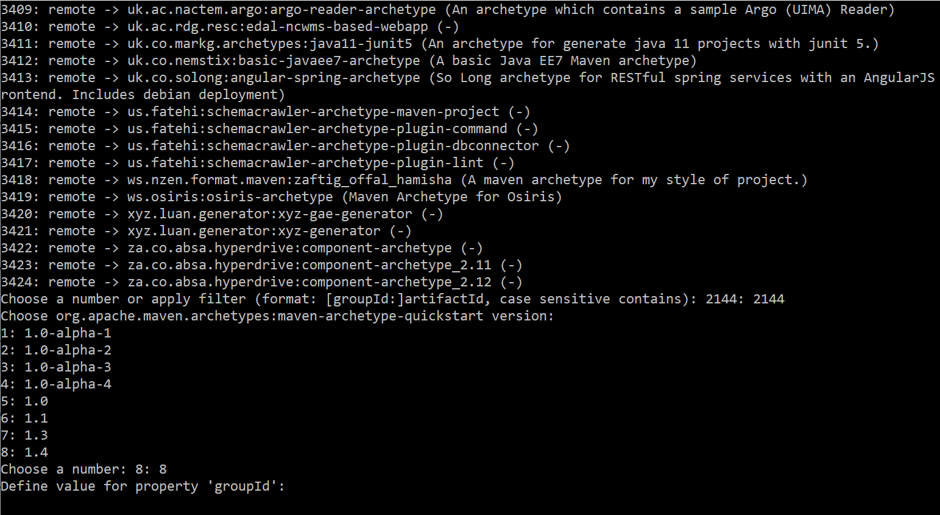

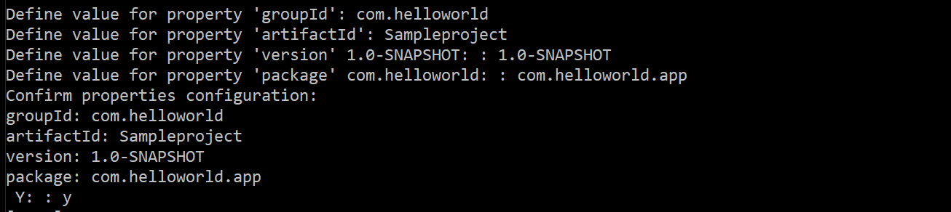

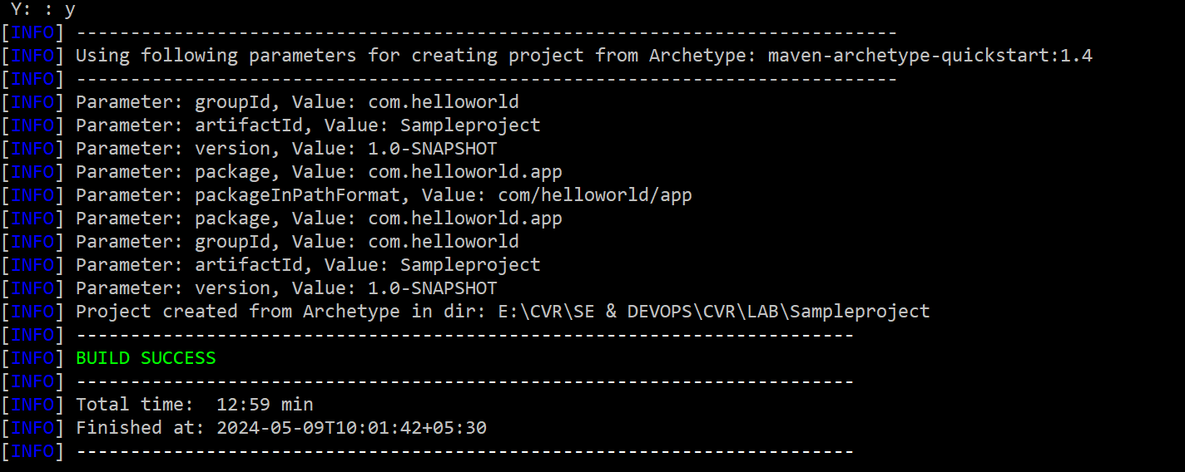

The project is generated at the specified location

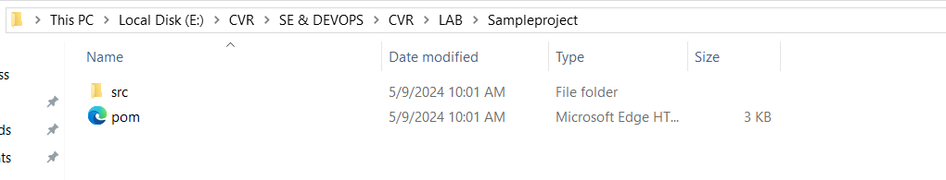

## Maven Build Lifecycle

A Build Lifecycle is a well-defined sequence of phases, which define the order in which the goals are to be executed. Here phase represents a stage in life cycle.

1. validate - validate the project is correct and all necessary information is available

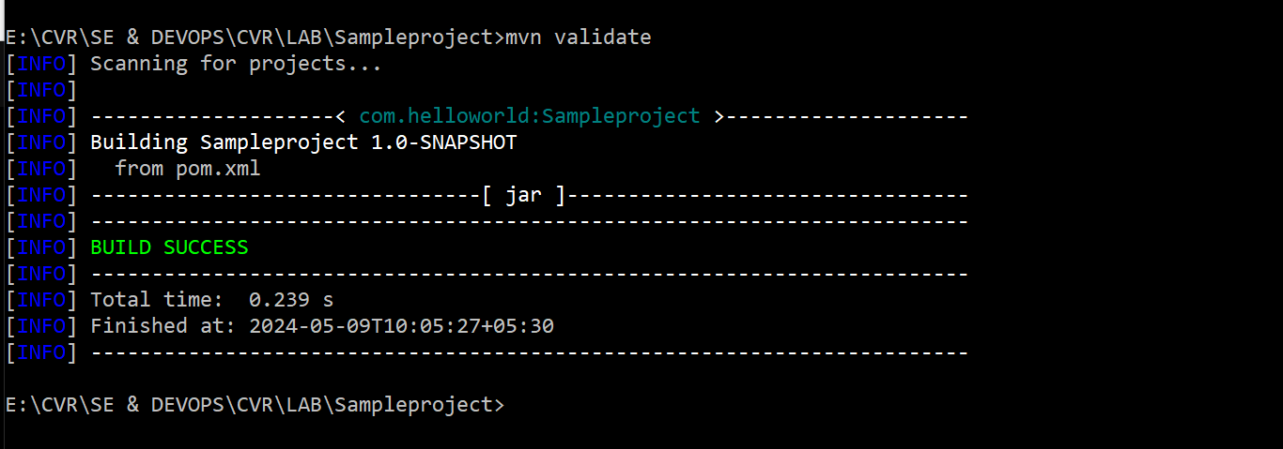

1. compile - compile the source code of the project

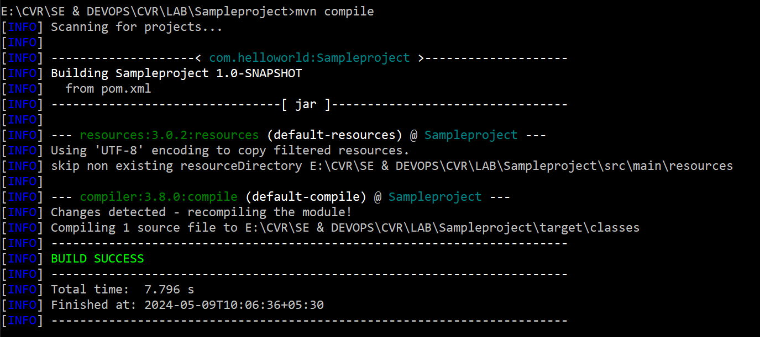

3.test - test the compiled source code using a suitable unit testing framework. These tests should not require the code be packaged or deployed

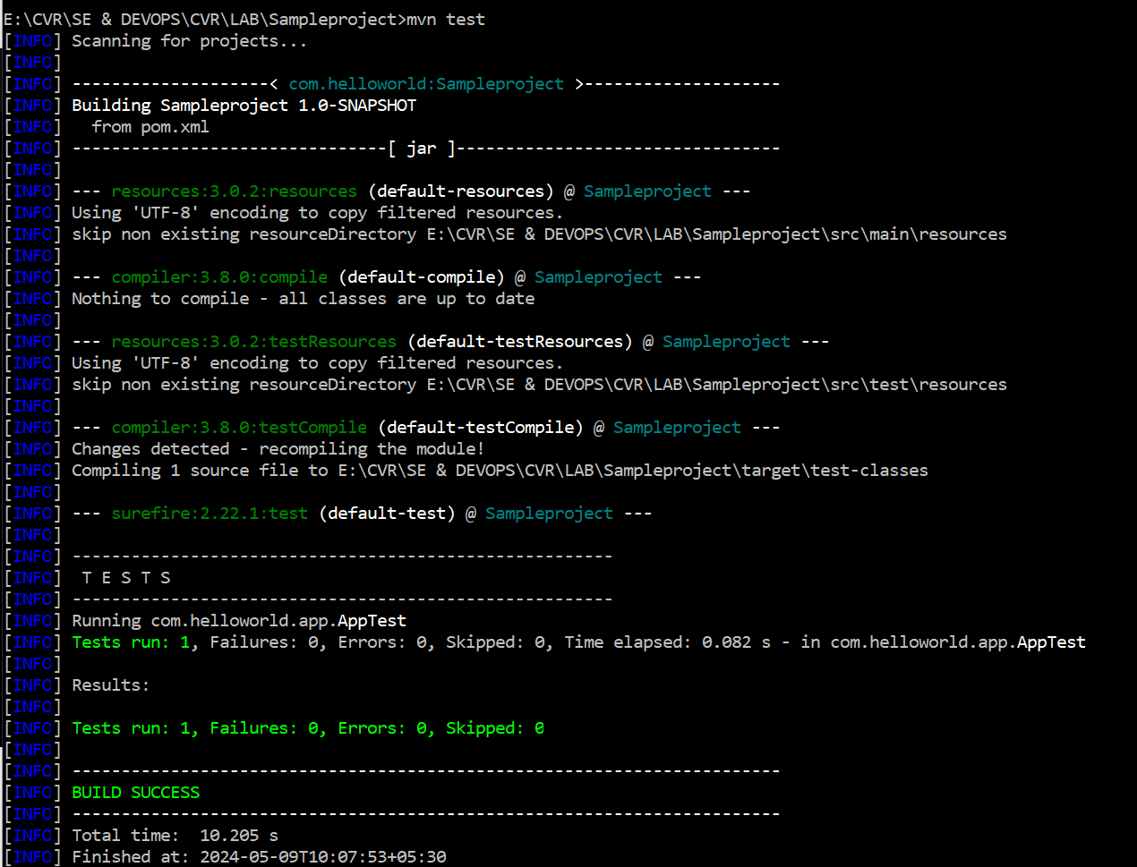

1. package - take the compiled code and package it in its distributable format, such as a JAR.

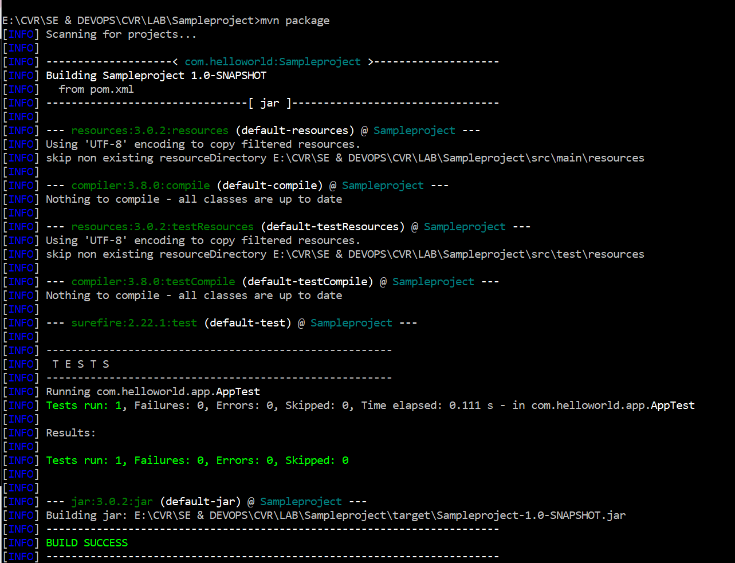

1. verify - run any checks on results of integration tests to ensure quality criteria are met

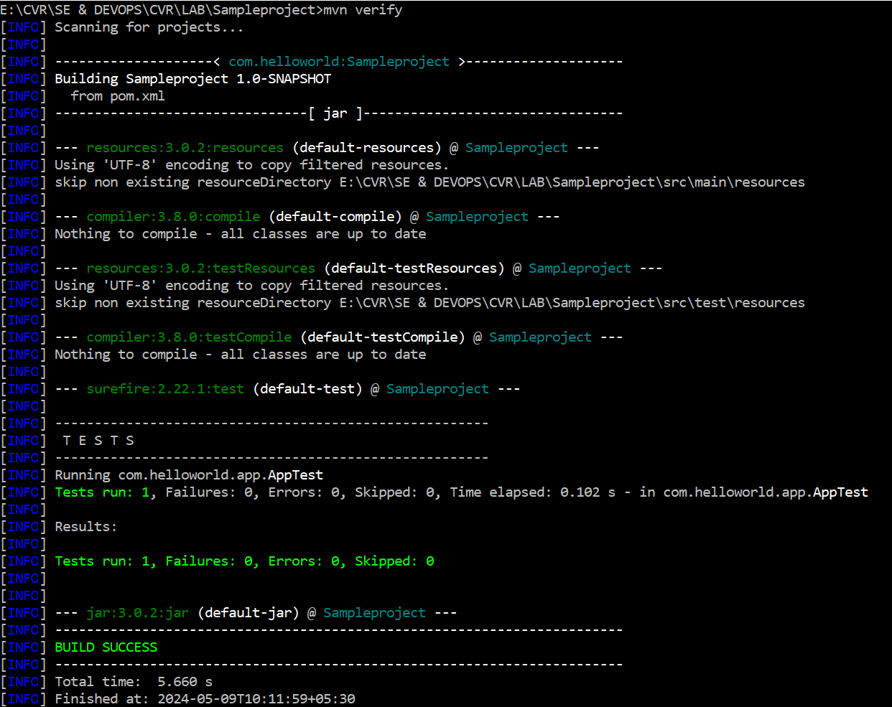

1. install - install the package into the local repository, for use as a dependency in other projects locally

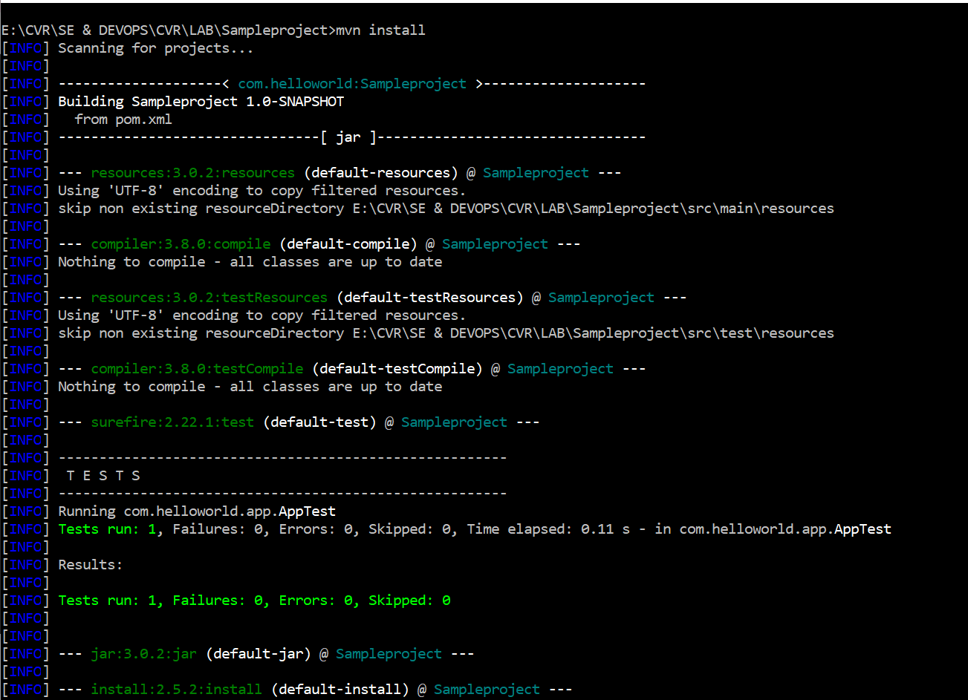

After the build is successful, you can run the application by executing the following command from the project root directory

